**FLORAL FIESTA: AN ONLINE**

**PLANT ORDERING APP**

**A PROJECT REPORT**

***Submitted by***

**JERIN BS (210701095)**

**KEERTHANA J (210701118)**

**JECIYAZHINI J (210701089)**

***in partial fulfilment of the course***

**CS19621 – PROFESSIONAL READINESS FOR INNOVATION, EMPLOYABILITY AND ENTREPRENEURSHIP**

***for the award of the degree***

***of***

**BACHELOR OF ENGINEERING**

**IN**

**COMPUTER SCIENCE AND ENGINEERING**



**MAY 2024**

**BONAFIDE CERTIFICATE**

Certified that this project **“FLORAL FIESTA: AN ONLINE PLANT ORDERING APP”** is the bonafide work of **“JERIN BS”, “JECIYAZHINI J”** and **“KEERTHANA J”** who carried out the project work under my supervision.

**SIGNATURE**

**K. ANAND M.E, Ph.D.,**

Professor

Dept. of Computer Science and Engineering,

Rajalakshmi Engineering College,

Thandalam,

Chennai - 602105

Submitted to ANNA UNIVERSITY for Project and Viva Voce Examination for the subject Professional Readiness for Innovation, Employability and Entrepreneurship held on __________________.

**INTERNAL EXAMINER**  **EXTERNAL EXAMINER**

**ABSTRACT**

Floral Fiesta is an innovative mobile application designed to enhance the buying and selling experience for plant enthusiasts by creating a seamless platform for interaction between plant vendors and customers. This application stands out by utilizing location-based data, which allows users to efficiently filter and locate nearby plant vendors. By leveraging GPS technology, Floral Fiesta ensures that users can easily find vendors within their vicinity, making the process of purchasing plants more convenient and accessible. One of the core features of Floral Fiesta is its sophisticated delivery system. The app intelligently matches the right delivery agents to each order, ensuring that plants are transported safely and arrive in optimal condition.

This feature addresses a common concern among plant buyers, who often worry about the potential damage during transit. By selecting appropriate delivery agents, the app ensures that plants are handled with care, preserving their health and appearance upon arrival. In addition to its buying and selling functionalities, Floral Fiesta serves as a comprehensive resource for plant care. The app provides detailed information about the specific requirements of various plants, including their needs for water, sunlight, soil type, and other critical factors. Floral Fiesta's user-friendly interface and rich feature set create a holistic platform that not only facilitates transactions but also fosters a community of informed and engaged plant lovers. By combining market accessibility, reliable delivery, and educational resources, the app supports users throughout their entire plant care journey, from purchase to maintenance. This comprehensive approach ensures that customers have a positive experience and are equipped with the knowledge to successfully grow and care for their botanical collections.

**ACKNOWLEDGEMENT**

We express our heartfelt gratitude to our esteemed chairman, **Mr. MEGANATHAN S**, and the chairperson, **Dr. THANGAM MEGANATHAN M**, for their timely support and encouragement.

We are deeply grateful to our respected principal, **Dr. MURUGESAN S N**, for his able support and guidance.

We owe a special debt of thanks to our Head of the Department, **Dr. KUMAR P M.E Ph.D.**, for his unwavering support throughout our project.

Our sincere thanks go to our internal guide, **Dr.** **K. ANAND M.E, Ph.D.**, for his valuable guidance and motivation during the completion of this project.

We also extend our sincere appreciation to our family members, friends, and other staff members of the Computer Science Engineering department.

**JERIN B S (210701095)**

**KEERTHANA J (210701118)**

**JECIYAZHINI J (210701089)**

**TABLE OF CONTENTS**

|  |  |  |
| --- | --- | --- |
| CHAPTER NO. | TITLE | PAGE NO. |
|  | **ABSTRACT** | **(iii)** |
| I | **INTRODUCTION**1.1 DESCRIPTION1.2 SCOPE OF WORK1.3 PROBLEM STATEMENT 1.4 AIM & OBJECTIVE | **1**  2  3  4 |
| II | **SYSTEM SPECIFICATIONS**2.1 HARDWARE SPECIFICATIONS 2.2 SOFTWARE SPECIFICATIONS | **5** |
| III | **SYSTEM DESIGN**3.1 ARCHITECTURE DIAGRAM 3.2 SEQUENCE DIAGRAM | **6** 7 |
| IV | **MODULE DESCRIPTION**4.1 LOCATION BASED FILTER4.2 VENDORS AND DELIVERY AGENTS 4.3 PLANT REQUIREMENTS FEED | **8** 9  10 |
| V | **SOURCE CODE**5.1 MAIN5.2 PLANT MODEL 5.3 PLANT CARD | **11** 12 |
| VI | **SAMPLE OUTPUT** | **16** |
| VII | **CONCLUSION & FUTURE ENHANCEMENTS** | **21** |

**LIST OF FIGURES**

|  |  |  |
| --- | --- | --- |
| **Figure**  **No.** | **Figure Description** | **Page No.** |
| 1 | Architecture Diagram | 6 |
| 2 | Sequence Diagram | 7 |
| 3 | Welcome Page | 16 |
| 4 | Signup Page | 17 |
| 5 | Home Page | 18 |
| 6 | Plant Details Page | 19 |
| 7 | Cart Page | 20 |

**LIST OF ABBREVIATIONS**

|  |  |
| --- | --- |
| **ABBREVIATION** | **DEFINITION** |
| AR | Augmented Reality |
| VR | Virtual Reality |
| DB | Data Base |
| API | Application Programming Interface |
| CPU | Central Processing Unit |
| RAM | Random Access Memory |
| GB | Giga Byte |
| V<n> | Version Number |

**CHAPTER I**

**INTRODUCTION**

**1.1 DESCRIPTION**

Floral Fiesta is an innovative plant-selling application that transforms the way plant vendors and customers interact, making the process of buying and selling plants more efficient and enjoyable. Designed with user convenience in mind, the app employs location-based data to help customers easily filter and find plant vendors in their vicinity. This feature significantly enhances the shopping experience by allowing users to quickly locate nearby sources of a diverse range of plants, supporting local businesses and ensuring faster access to desired products.

One of the core functionalities of Floral Fiesta is its advanced delivery system. The app intelligently matches each plant order with the most appropriate delivery agent, taking into account various factors such as the route, delivery speed, and specific handling requirements for delicate plants. This careful matching process ensures that plants are transported in a manner that preserves their health and quality, alleviating common concerns about potential damage during transit. Customers can trust that their plants will arrive in excellent condition, ready to thrive in their new environment. Beyond facilitating efficient transactions and reliable deliveries, Floral Fiesta also serves as an educational platform for plant care. The app provides detailed information about the specific needs of various plants, covering essential aspects such as watering schedules, sunlight exposure, soil types, and other critical care requirements.

This comprehensive resource empowers users with the knowledge they need to maintain the health and vitality of their plants, whether they are beginners or experienced plant enthusiasts. By offering this guidance, Floral Fiesta ensures that customers can make informed decisions and provide the best possible care for their plants. Floral Fiesta’s user-friendly interface is designed to make the entire process straightforward and enjoyable. From browsing through a wide selection of plants and filtering by location to placing orders and receiving expert care tips, every feature of the app is geared towards enhancing the user experience. This holistic approach not only simplifies the buying and selling of plants but also fosters a community of informed and engaged plant lovers.

**1.2 SCOPE OF WORK**

Floral Fiesta aims to revolutionize the plant-selling experience by offering a comprehensive mobile application that bridges the gap between plant vendors and customers. At its core, Floral Fiesta utilizes cutting-edge location-based data technology to empower users in their search for plants and vendors. This means that users can easily filter their searches based on their current location, enabling them to discover nearby vendors and plant options effortlessly. This feature not only enhances convenience but also fosters a sense of community by supporting local businesses and encouraging sustainable sourcing practices. Integral to the success of Floral Fiesta is its sophisticated delivery system. Recognizing the importance of ensuring that plants arrive in optimal condition, the app meticulously matches each order with the most suitable delivery agent. Factors such as proximity, route efficiency, and handling requirements are carefully considered to guarantee safe and timely delivery. By prioritizing the well-being of the plants during transit, Floral Fiesta addresses a common concern among buyers and cultivates trust and confidence in the platform.

Moreover, Floral Fiesta goes beyond being a mere marketplace; it serves as an educational hub for plant care. With a vast database of plant species and detailed care instructions, users can access valuable information on how to nurture their plants effectively. Whether it's understanding watering schedules, sunlight preferences, or soil types, the app provides the knowledge needed to cultivate thriving greenery. This educational component not only empowers users to make informed decisions but also fosters a deeper appreciation for the botanical world. In terms of development, Floral Fiesta prioritizes user experience and technical excellence. A user-friendly interface is meticulously crafted to ensure intuitive navigation and seamless interaction for both vendors and customers. Behind the scenes, a robust backend system is implemented to manage user data, orders, and delivery logistics securely. Integration with third-party APIs further enhances functionality, enabling features such as real-time tracking and secure payment processing.

**1.3 PROBLEM STATEMENT**

Floral Fiesta, a plant selling application, serves as a platform for vendors and customers to connect and transact. Utilizing location-based data, the app offers filters for plant selection and facilitates vendor discovery, ensuring users find the plants they desire from nearby sellers. Additionally, the app coordinates delivery agents to ensure the safe and timely transportation of plants to customers' doorsteps. Despite these functionalities, several areas for improvement have been identified.

Firstly, the user interface and experience require enhancement to optimize navigation and engagement. Accuracy and relevance of location-based data need improvement to enhance search results. Streamlining the delivery process is imperative, necessitating the optimization of delivery agent selection and route planning to minimize delays. Plant care information accessibility, including watering schedules and sunlight requirements, could be improved, potentially through personalized care reminders. Fostering better vendor-customer interaction is essential, possibly through features like live chat support and feedback mechanisms. Ensuring scalability and performance under varying loads is crucial to accommodate a growing user base. Security measures must be robust to protect user data and transactions. Establishing feedback mechanisms will enable iterative improvements based on user suggestions and preferences, ultimately aiming for a more user-friendly and efficient plant selling platform.

**1.4 AIM & OBJECTIVE**

Floral Fiesta endeavours to transform the plant buying and selling landscape by establishing a user-centric platform where vendors and customers seamlessly interact, facilitated by location-based data for optimized plant discovery, vendor connectivity, and efficient delivery management. With the overarching aim in mind, Floral Fiesta sets out to achieve several key objectives. Firstly, the application aims to enhance user experience by refining the user interface and navigation, ensuring a smooth and engaging interaction for both vendors and customers. Secondly, the platform seeks to streamline vendor-customer interaction, facilitating seamless communication and transaction processes to foster trust and satisfaction among users.

Utilizing location-based data, Floral Fiesta aims to personalize the plant discovery process, providing tailored plant recommendations and optimizing vendor discovery for users based on their geographical location. Moreover, the platform endeavours to ensure delivery efficiency by identifying and coordinating suitable delivery agents, thereby ensuring secure and timely plant transportation to customers' doorsteps. Another critical objective is to provide comprehensive plant information, including details on watering schedules, sunlight requirements, and care instructions, empowering customers to make informed purchasing decisions and effectively nurture their plants post-purchase. Concurrently, Floral Fiesta places a strong emphasis on data accuracy and security, safeguarding user data and transaction details to instil confidence and trust among users. Finally, the platform aims to drive user engagement and retention by implementing features such as personalized plant care reminders, live chat support, and feedback mechanisms, thereby fostering a vibrant community of plant enthusiasts. Through the attainment of these objectives, Floral Fiesta endeavours to establish itself as the premier destination for plant enthusiasts, offering a seamless and enriching buying and selling experience while nurturing a shared passion for plants and gardening.

# **CHAPTER II**

**SYSTEM SPECIFICATIONS**

**2.1**  **HARDWARE SPECIFICATIONS**

|  |  |
| --- | --- |
| CPU | Intel Core i3 12Gen+ or ARM M1 |
| RAM | 12 GB+ DDR4 |
| STORAGE | 8 GB |

**2.2**  **SOFTWARE SPECIFICATIONS**

|  |  |
| --- | --- |
| OS | Windows 10 or higher |
| IDE | Android Studio Iguana |
| JDK | V17.0+ |
| ANDROID | Nougat v7.0+ |

**CHAPTER III**

**SYSTEM DESIGN**

**3.1 ARCHITECTURE DIAGRAM**

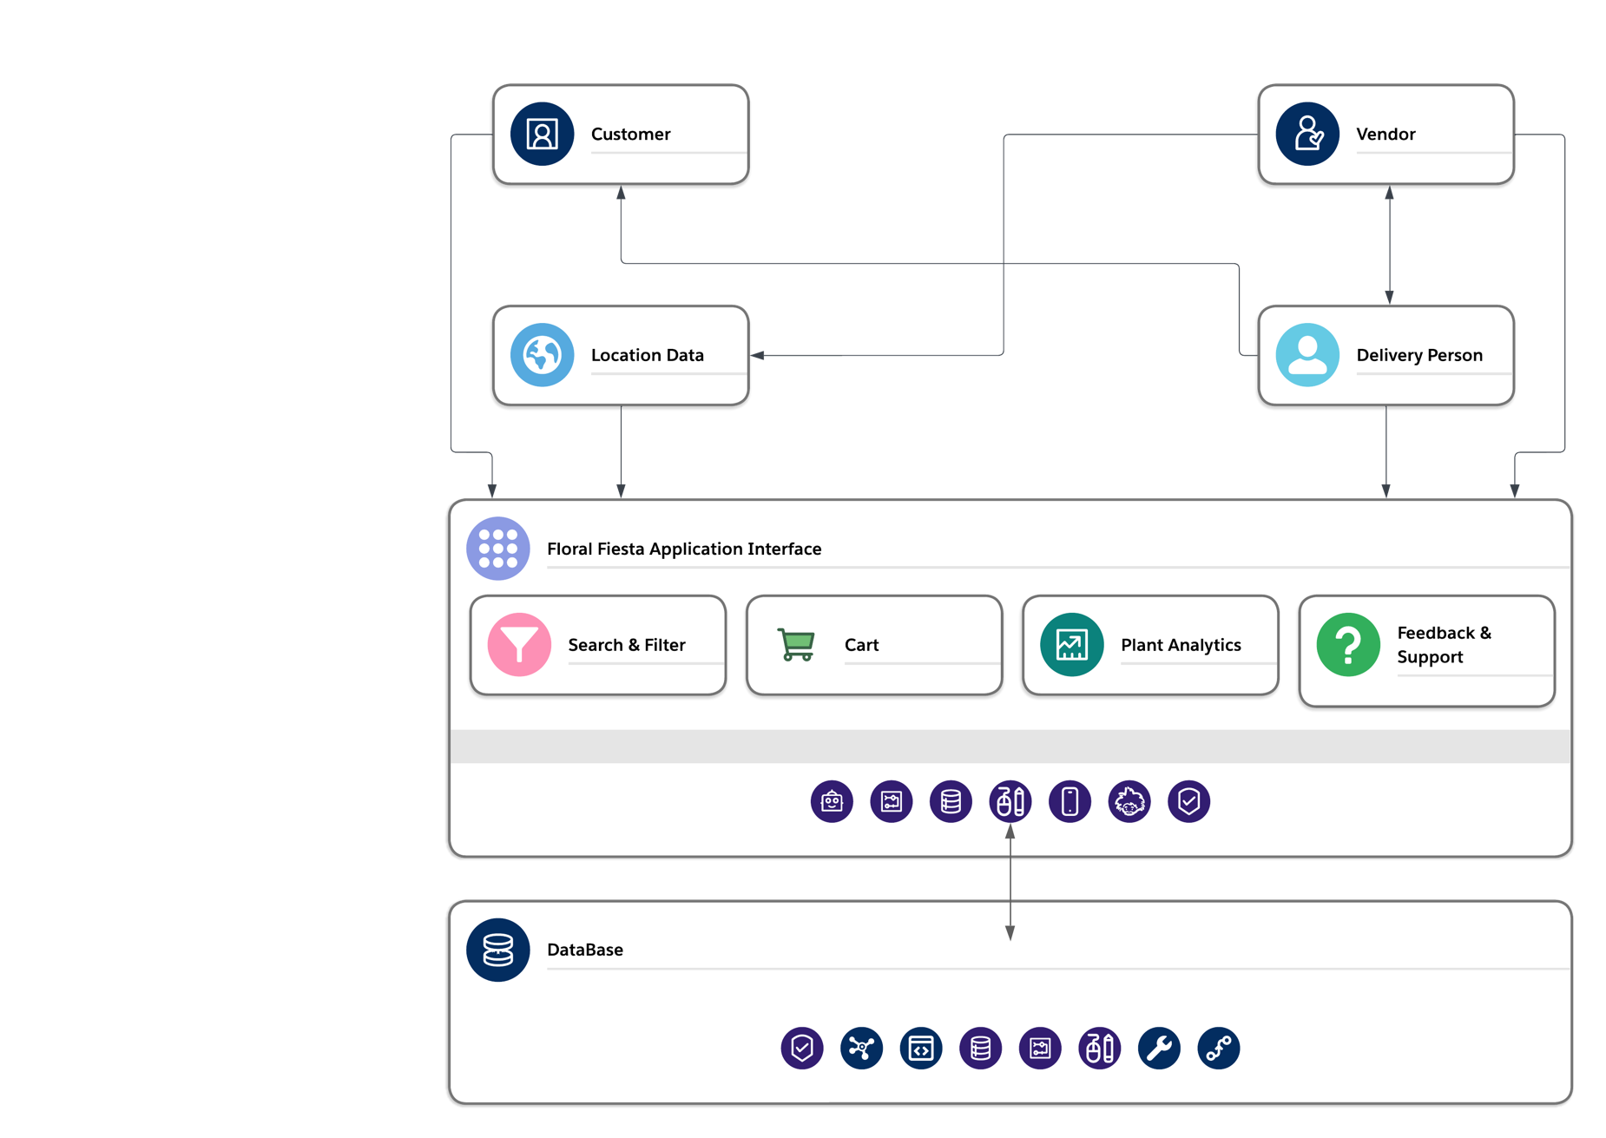

**3.2 SEQUENCE DIAGRAM**

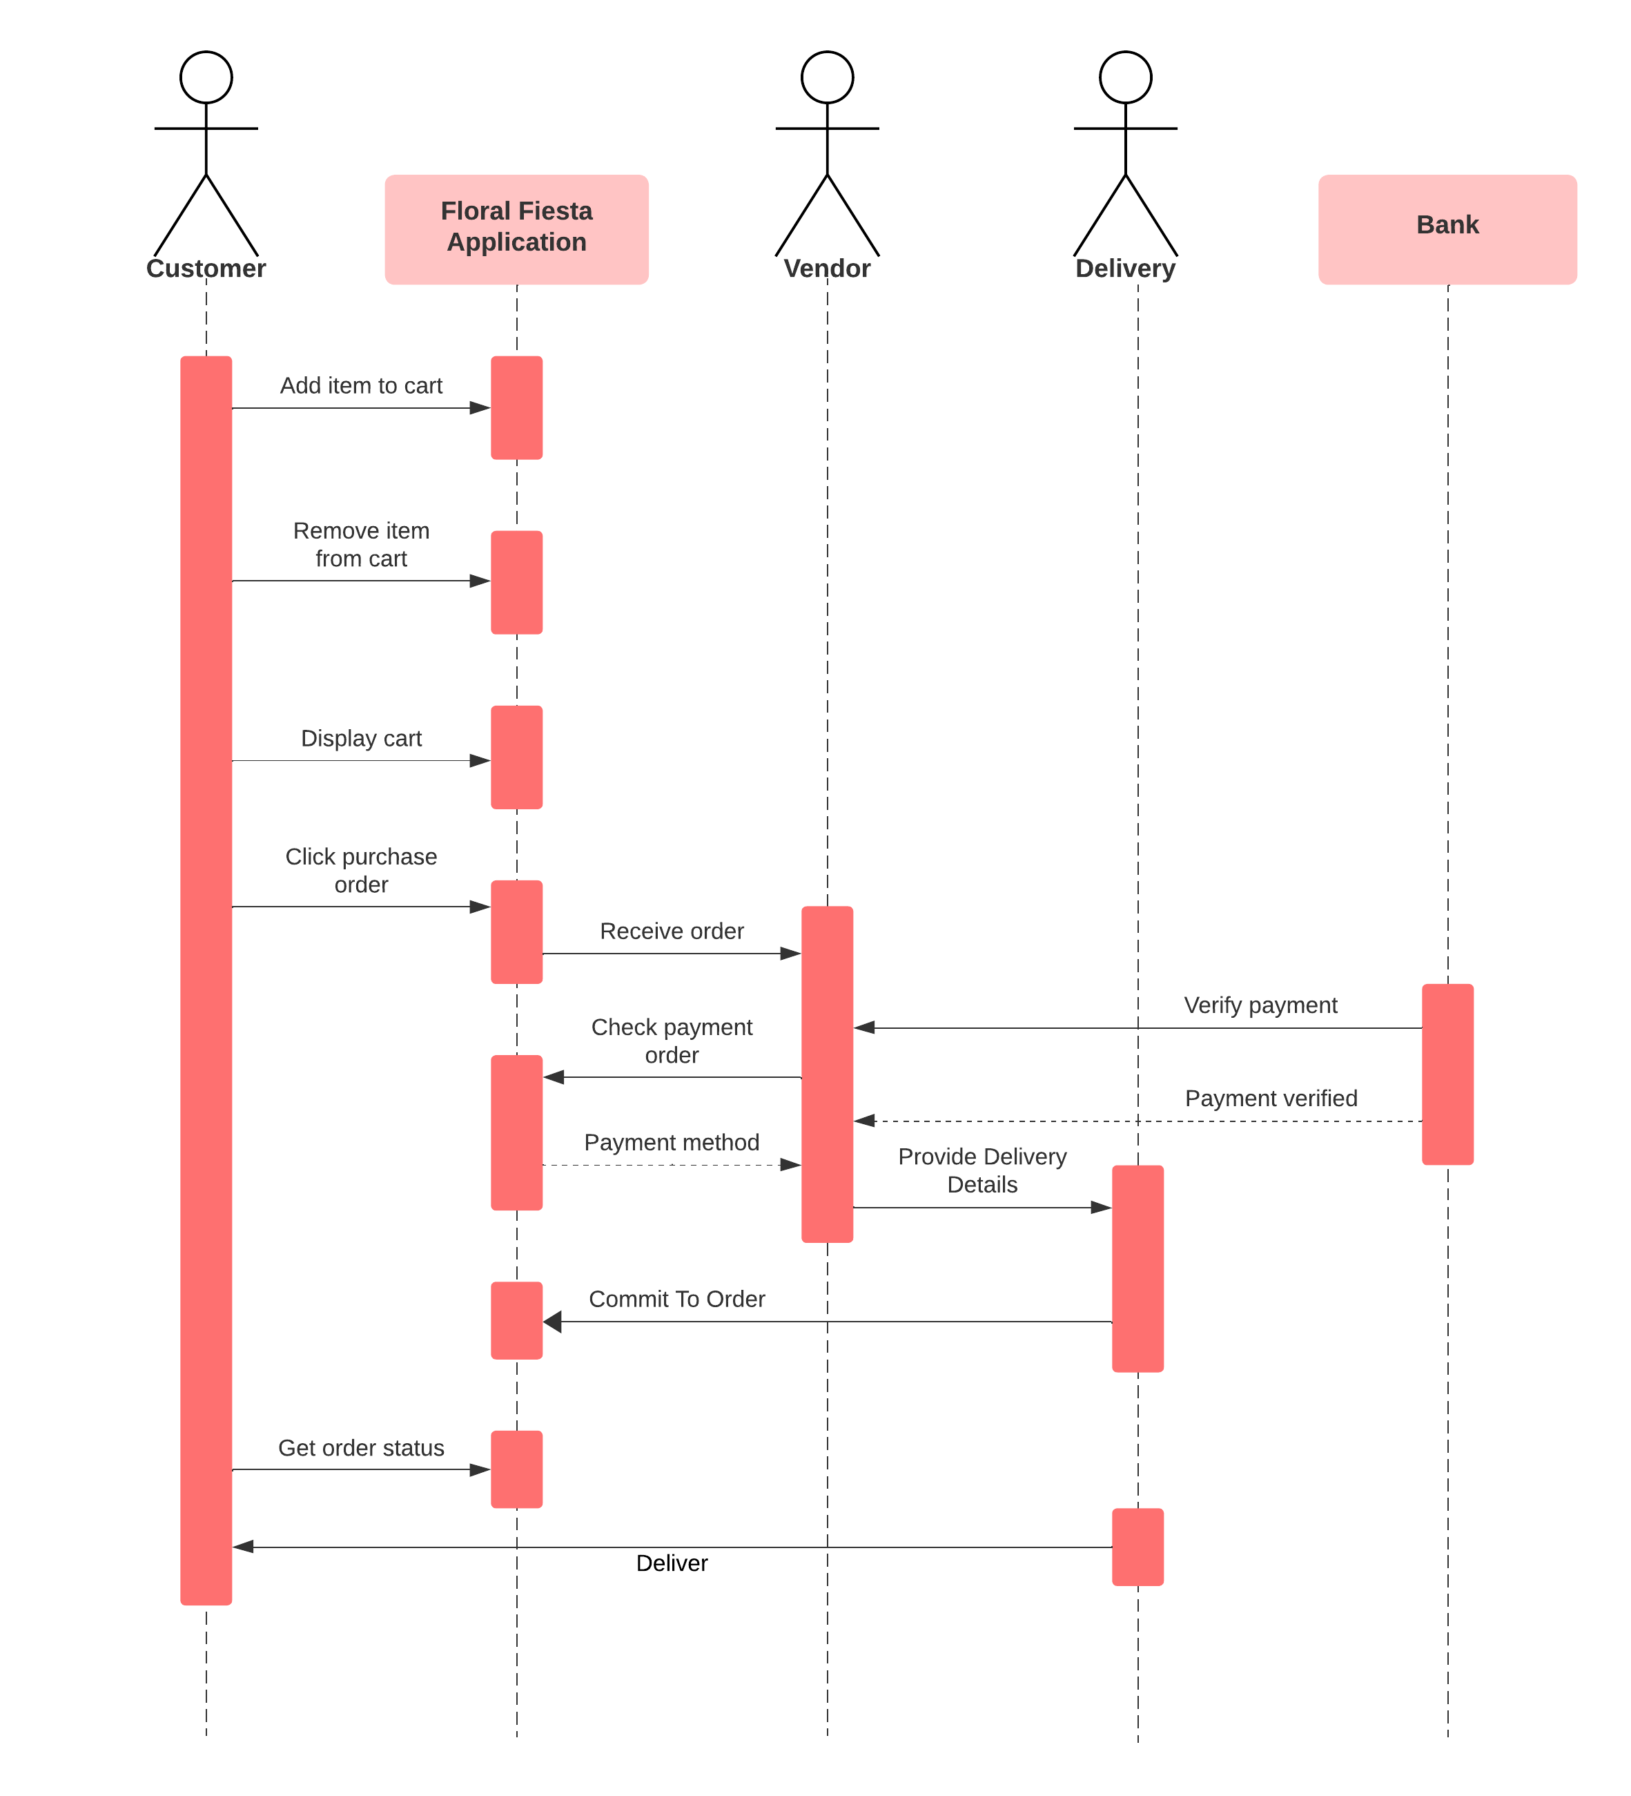

**CHAPTER IV**

**MODULE DESCRIPTION**

**4.1 LOCATION BASED FILTER**

The Location Based Filter module is a sophisticated feature within Floral Fiesta that harnesses cutting-edge geolocation technology to revolutionize the plant browsing experience. This module operates on the principle of proximity, allowing users to effortlessly discover plant vendors and offerings in their immediate vicinity. By leveraging precise location data, users can access a curated selection of plants available from vendors nearby, eliminating the need for extensive manual searches and enhancing convenience in plant procurement.

One of the key advantages of the Location Based Filter module is its ability to provide a tailored and personalized browsing experience for users. By analysing the user's current geographical location, the module delivers plant recommendations that are specifically suited to the local climate and environmental conditions. For example, users residing in regions with specific weather patterns or soil types will receive plant suggestions that thrive in such conditions, ensuring greater success and satisfaction with their plant purchases.

Furthermore, the Location Based Filter module empowers users with the flexibility to refine their plant search based on various criteria such as plant type, size, and price range, all within the context of their current location. This level of customization allows users to find plants that meet their specific preferences and requirements while still benefiting from the convenience of nearby vendor options. Overall, the Location Based Filter module enhances the plant buying experience by simplifying the search process, providing relevant recommendations, and fostering a deeper connection between users and their local plant community.

**4.2 VENDORS AND DELIVERY AGENTS**

At the heart of Floral Fiesta lies the Vendors and Delivery Agents module, a dynamic platform that facilitates seamless interactions between plant vendors and customers. This module serves as a virtual marketplace where vendors can showcase their diverse range of plant offerings and engage directly with potential buyers. Through vendor profiles, users gain access to detailed information about each vendor, including their plant inventory, pricing, and customer reviews, enabling informed decision-making and fostering transparency in transactions.

Additionally, the Vendors and Delivery Agents module plays a crucial role in managing the logistics of plant delivery. When a purchase is made, the module automatically identifies and coordinates with the most suitable delivery agent based on factors such as proximity to the vendor's location and availability. This seamless integration of delivery logistics ensures that plants are transported safely and efficiently from the vendor to the customer, minimizing delays and enhancing overall customer satisfaction.

Moreover, the Vendors and Delivery Agents module promotes trust and reliability within the Floral Fiesta community by implementing robust measures to safeguard the integrity of transactions. Users can track the status of their orders in real-time, receive notifications about delivery updates, and provide feedback on their purchasing experience, thereby fostering accountability and accountability among vendors and delivery agents alike.

**4.3 PLANT REQUIREMENTS FEED**

The Plant Requirements Feed module serves as a comprehensive resource within Floral Fiesta, providing users with invaluable insights into the care requirements of various plant species. Through a vast database of plant care information, users can access detailed guidelines on factors such as watering schedules, sunlight preferences, soil conditions, and pest management strategies, among others. This wealth of knowledge empowers users to make informed decisions when selecting plants, ensuring compatibility with their living environment and personal care preferences.

One of the key features of the Plant Requirements Feed module is its user-friendly interface, which allows users to easily search for specific plants or browse through curated collections based on categories such as indoor plants, outdoor plants, and rare species. Each plant listing includes comprehensive care instructions written in clear and accessible language, supplemented by visuals such as images and videos to aid in understanding. Additionally, the Plant Requirements Feed module offers personalized plant care recommendations based on user preferences and environmental factors. By inputting details such as their location, climate zone, and available sunlight, users can receive tailored suggestions for plants that are well-suited to their unique circumstances. This level of customization ensures that users can confidently select plants that not only match their aesthetic preferences but also thrive in their specific living environment.

Furthermore, the Plant Requirements Feed module fosters a sense of community among users by providing opportunities for knowledge sharing and collaboration. Users can engage in discussions, ask questions, and share their own experiences and tips for plant care, creating a vibrant and supportive ecosystem of plant enthusiasts within the Floral Fiesta community. Overall, the Plant Requirements Feed module serves as an indispensable tool for users seeking to cultivate healthy and thriving plant ecosystems in their homes and gardens.

**CHAPTER V**

**SOURCE CODE**

**5.1 MAIN (main.dart)**

import 'package:flutter/material.dart';

import 'package:floral_fiesta/Pages/cart_page.dart';

import 'package:floral_fiesta/Pages/home_page.dart';

import 'package:floral_fiesta/Pages/login_page.dart';

import 'package:floral_fiesta/Pages/main_page.dart';

import 'package:floral_fiesta/Pages/signup_page.dart';

void main() {

runApp(const MyApp());

}

class MyApp extends StatelessWidget {

const MyApp({super.key});

@override

Widget build(BuildContext context) {

return MaterialApp(

debugShowCheckedModeBanner: false,

title: 'Flutter Demo',

theme: ThemeData(

primarySwatch: Colors.blue

),

home: const LoginPage(),

routes:{

LoginPage.id: (context) => const LoginPage(),

SignupPage.id: (context) => const SignupPage(),

MainPage.id: (context) => const MainPage(),

HomePage.id: (context) => const HomePage(),

CartPage.id: (context) => const CartPage(),

}

);

}

}

**5.2 PLANT MODEL (plant.dart)**

class Plant {

final String plantType;

final String plantName;

final double plantPrice;

final String image;

final double stars;

final PlantMetrics metrics;

Plant({

required this.plantType,

required this.plantName,

required this.plantPrice,

required this.image,

required this.stars,

required this.metrics,

});

}

class PlantMetrics {

final String height;

final String humidity;

final String width;

PlantMetrics(this.height, this.humidity, this.width);

}

**5.3 PLANT CARD (plant_card.dart)**

import 'package:flutter/cupertino.dart';

import '../constants.dart';

import 'curve.dart';

class PlantCard extends StatelessWidget {

const PlantCard({

required this.plantType,

required this.plantName,

required this.plantPrice,

required this.image,

required this.onTap,

super.key,

});

final String plantType;

final String plantName;

final double plantPrice;

final Image image;

final Function() onTap;

@override

Widget build(BuildContext context) {

return GestureDetector(

onTap: onTap,

child: Stack(

clipBehavior: Clip.none,

children: [

Container(

height: 220.0,

width: 185.0,

decoration: BoxDecoration(

color: kGinColor,

borderRadius: BorderRadius.circular(20.0),

),

child: CustomPaint(

painter: CurvePainter(),

),

),

Positioned(

// height: 240.0,

// width: 124.0,

left: 8.0,

bottom: 70.0,

child: Container(

constraints:

const BoxConstraints(maxWidth: 124.0, maxHeight: 240.0),

child: Hero(tag: plantName, child: image),

),

),

Positioned(

bottom: 0.0,

left: 0.0,

child: Container(

width: 185,

height: 60.0,

decoration: BoxDecoration(

borderRadius: BorderRadius.circular(20.0),

),

child: Padding(

padding:

const EdgeInsets.symmetric(vertical: 10.0, horizontal: 8.0),

child: Row(

crossAxisAlignment: CrossAxisAlignment.center,

mainAxisAlignment: MainAxisAlignment.spaceAround,

children: [

Flexible(

child: Column(

mainAxisAlignment: MainAxisAlignment.center,

crossAxisAlignment: CrossAxisAlignment.start,

children: [

Text(

plantType,

style: TextStyle(

color: kDarkGreenColor,

fontWeight: FontWeight.w400,

),

),

const SizedBox(height: 2.0),

Expanded(

child: Text(

plantName,

overflow: TextOverflow.fade,

maxLines: 1,

softWrap: false,

style: TextStyle(

color: kDarkGreenColor,

fontSize: 16.0,

fontWeight: FontWeight.w600,

),

),

),

],

),

),

Container(

padding: const EdgeInsets.symmetric(

vertical: 6.0,

horizontal: 10.0,

),

decoration: BoxDecoration(

color: kFoamColor,

borderRadius: BorderRadius.circular(20.0),

),

constraints: const BoxConstraints(maxWidth: 90.0),

child: Text(

'₹${plantPrice}0',

overflow: TextOverflow.ellipsis,

maxLines: 1,

softWrap: false,

style: TextStyle(

color: kDarkGreenColor,

fontWeight: FontWeight.w600,

fontSize: 12.8,

),

),

),

],

),

),

),

),

],

),

);

}

}

**CHAPTER VI**

**SAMPLE OUTPUT**

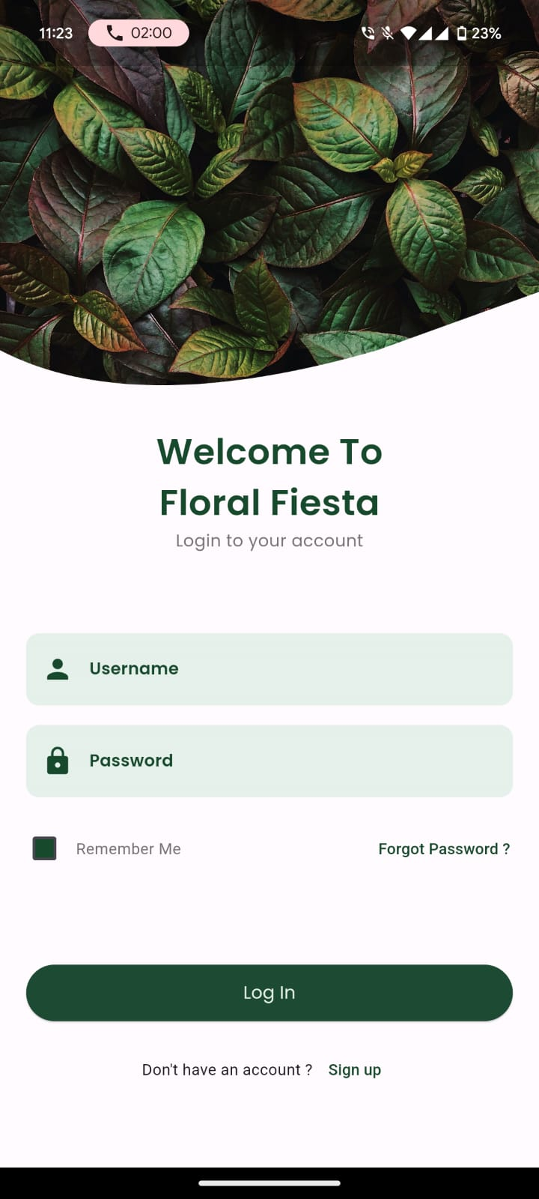

**Fig 7.1:** Welcome Page

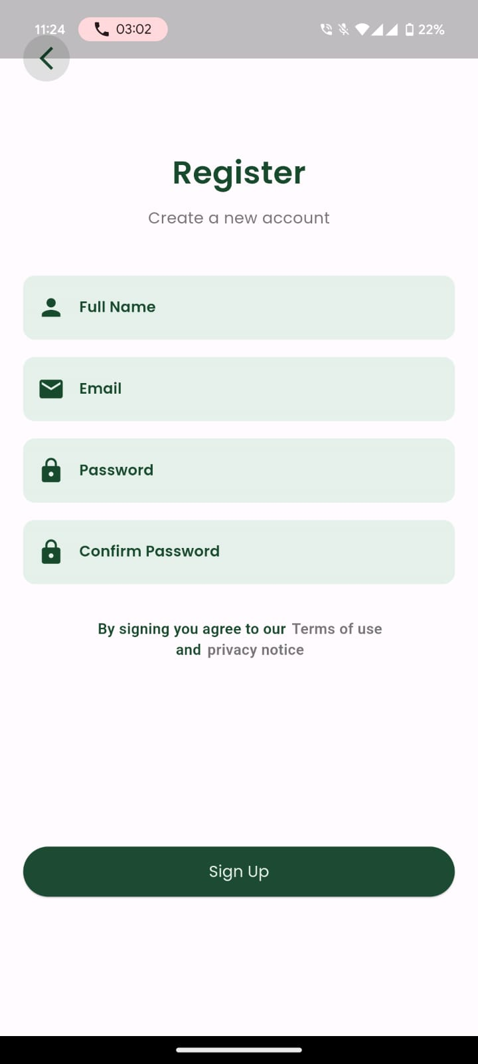

**Fig 7.2:** Signup Page

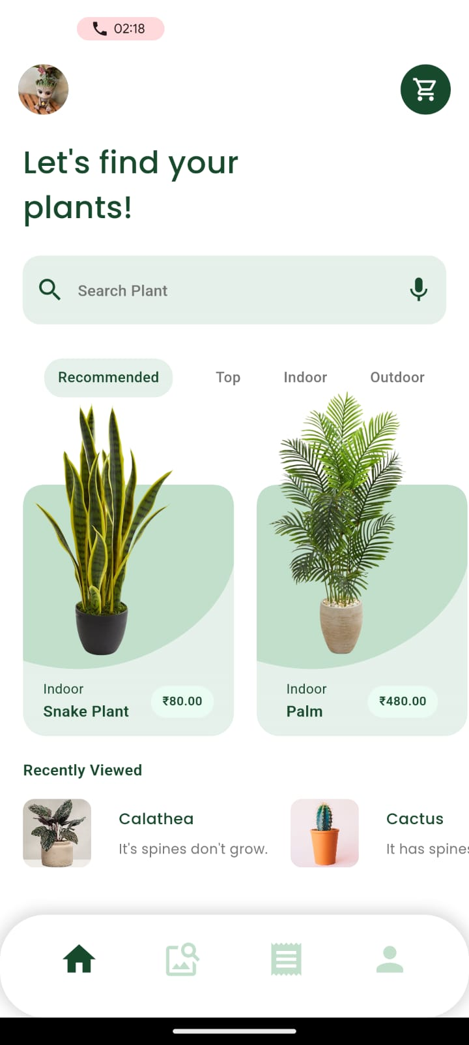

**Fig 7.3:** Home Page

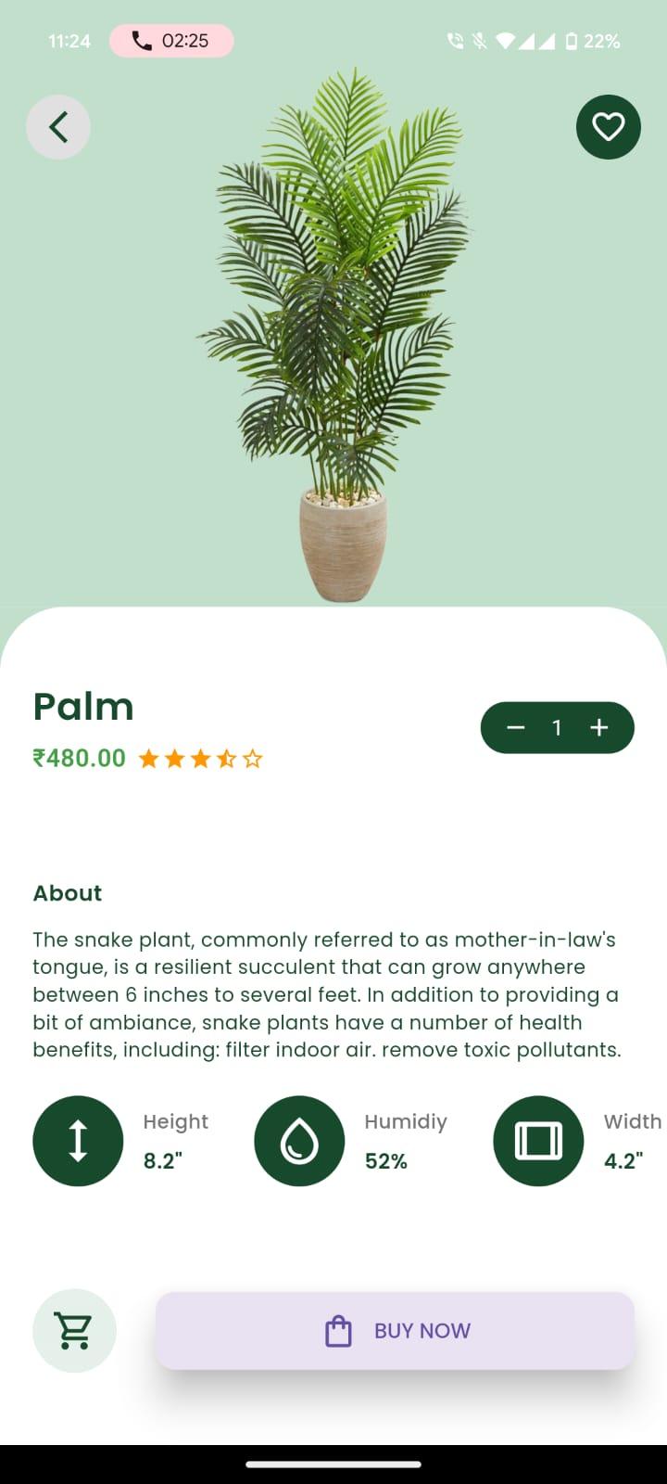

**Fig 7.4:** Plant Details Page

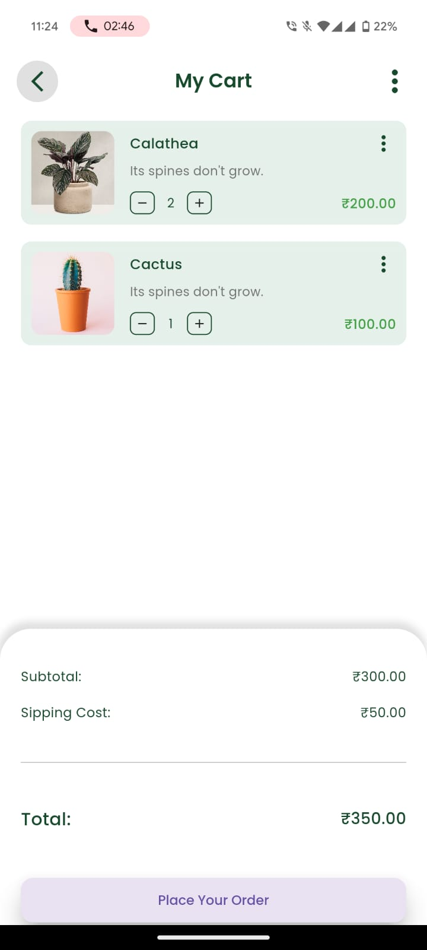

**Fig 7.5:** Cart Page

**CHAPTER VII**

**CONCLUSION & FUTURE ENHANCEMENTS**

In conclusion, Floral Fiesta has successfully transformed the plant buying and selling experience by providing a user-friendly platform for vendors and customers to interact and transact. Through the utilization of location-based data, the application offers efficient plant filters and vendor discovery, ensuring that users can easily find the plants they desire from nearby sellers. Moreover, the seamless coordination of delivery agents ensures the timely and secure transportation of plants to customers' doorsteps. Additionally, the app's provision of comprehensive plant care information, including watering schedules and sunlight requirements, empowers users to make informed purchasing decisions and nurture their plants effectively post-purchase. Overall, Floral Fiesta has significantly enhanced the convenience, accessibility, and satisfaction associated with buying and caring for plants, fostering a vibrant community of plant enthusiasts.

Looking ahead, Floral Fiesta has several opportunities for future enhancements to further elevate the user experience and expand its functionality. One potential enhancement could involve the integration of augmented reality (AR) technology, allowing users to visualize how different plants would look in their home environment before making a purchase. This immersive feature would provide users with a more interactive and engaging shopping experience.

Furthermore, the application could explore the implementation of community-driven features such as plant swapping or sharing, enabling users to connect with fellow plant enthusiasts and expand their plant collections through collaborative efforts. Additionally, incorporating machine learning algorithms could enhance the app's recommendation system, providing users with more personalized plant suggestions based on their browsing history, preferences, and environmental factors.

Moreover, expanding the app's database to include a wider variety of plant species, including rare and exotic plants, would cater to the diverse interests of users and further establish Floral Fiesta as a comprehensive destination for plant enthusiasts. Finally, enhancing the app's social features, such as user profiles, forums, and live events, would foster a stronger sense of community and engagement among users, encouraging knowledge sharing and collaboration in the world of plant care. Overall, these future enhancements hold the potential to elevate Floral Fiesta to new heights and solidify its position as the premier plant selling application in the market.